We’ve seen Learning rate or step size in Update equation of gradient descent, but because of this r, gradient descent can get into oscillation and never converge to minima or maxima. Let’s understand this.

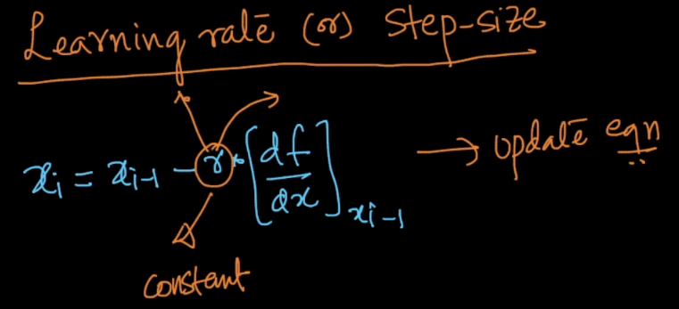

Suppose f(x) = x2 and therefore df/dx = 2x.

Let’s say r = 1 and first guessed x0 = 0.5.

Now we’ll find x1 using update equation, and x1 will be -0.5.

As we can see that our minima is at 0, but instead of that this give new x at -0.5.

Now let’s find x2, and x2 will be 0.5

Again we see that instead of going to 0, it goes to 0.5

So with each iteration it keeps oscillating at -0.5 and 0.5, and it will never converge at minima.

This problem is called **Oscillation problem.**

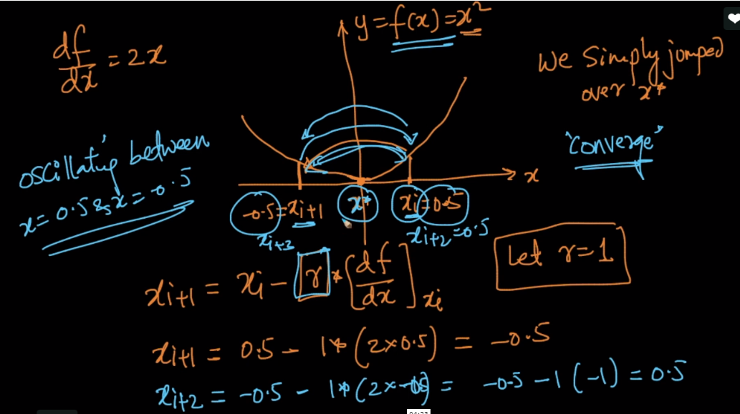

**How to deal with oscillation:**

As r is constant each time we are finding new x, so what we’ll do is we reduce **r**  with each iteration, so because of this it will not go into oscillation.

There are several functions available to reduce r with each iteration.

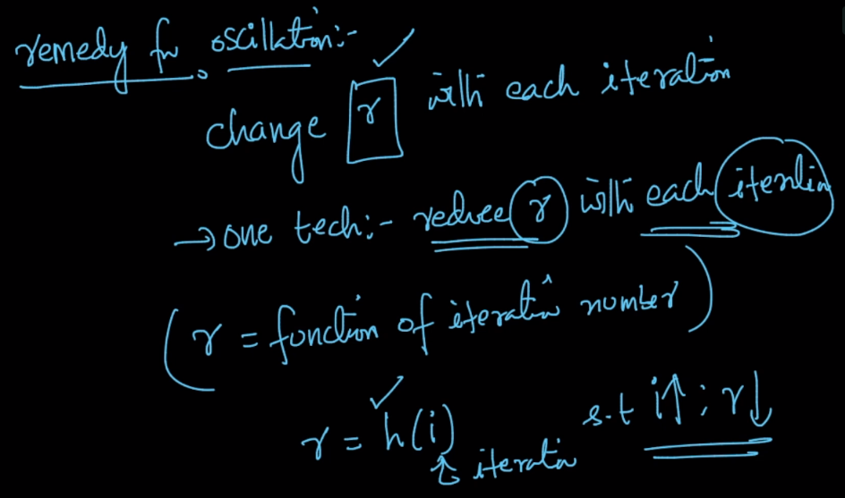

**Comments:**

**1)**

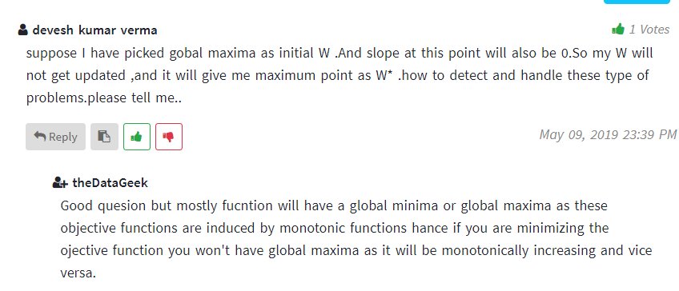

**2)**

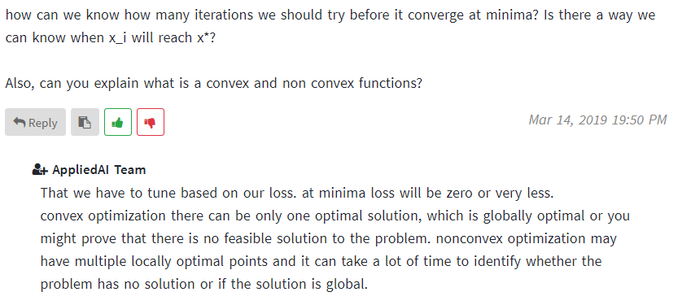

**3)**

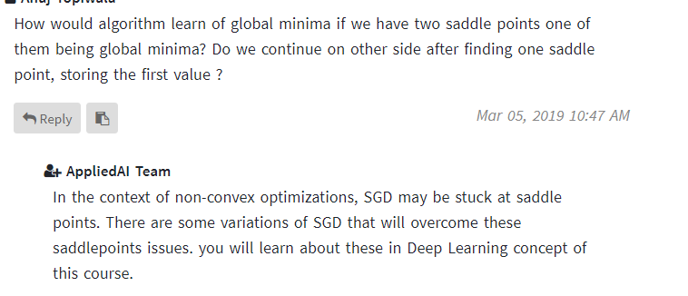

**4)**

